**Footprint**

* Cherno所Commit的代码，缺少layer->OnAttach，导致ImGui无法初始化

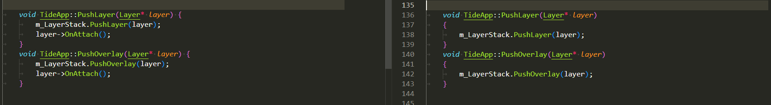

* 035 Createing an orthographic camera  
  正交视角的裁切范围误写成-1，导致视窗中无任何Fragment

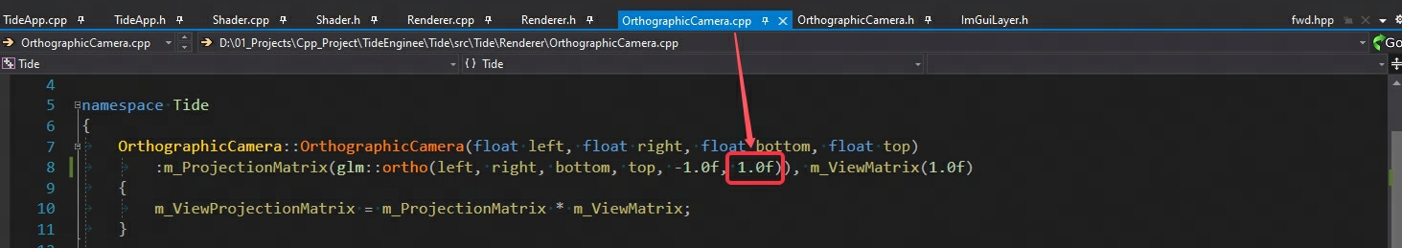

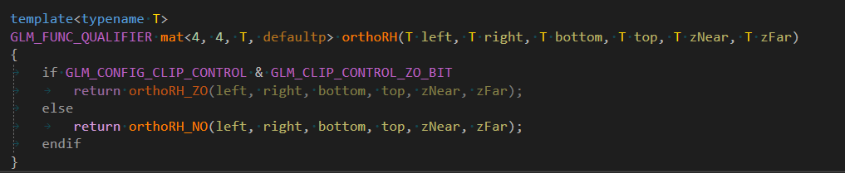

* 042 Inital Texture Support  
  从github拷贝nothing/stb_image后，若没有创建stb_image.cpp文件，则发生以下报错

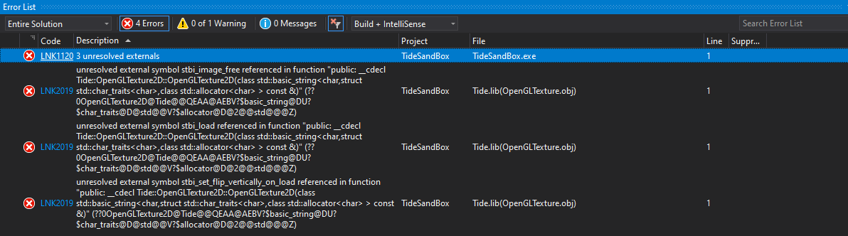

* 047 Camera Controller  
  才发现自定义TD_BIND_EVENT_FN一直误写成HZ_BIND_EVENT_FN



* 050 Create TideSandBox2D  
  若是忘记在TideSandBox2D项目上包含EntryPt头文件，链接时会缺少main函数

  
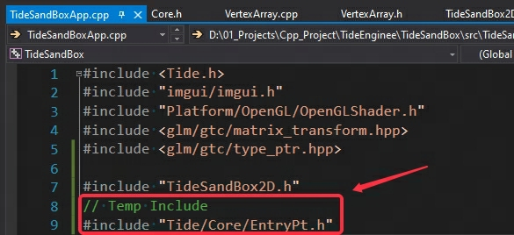  
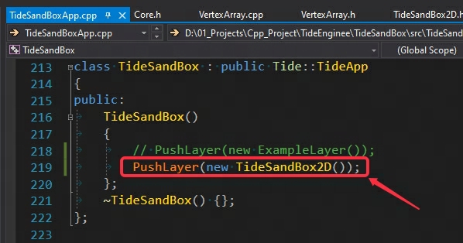

* 051 Started work on 2d renderer  
  glsl的加载路径不对(../shaders/..)，导致无法找到正确的filepath而引发异常

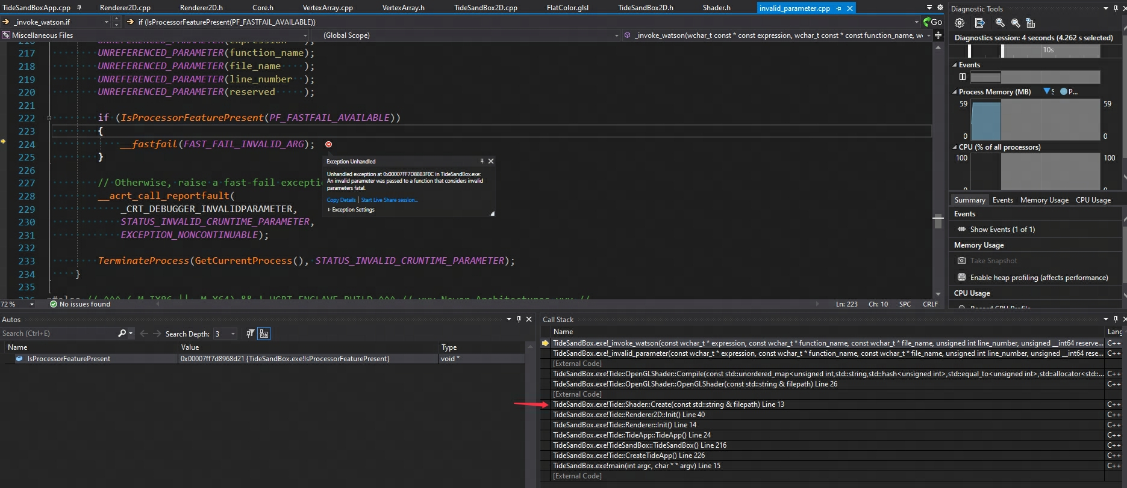

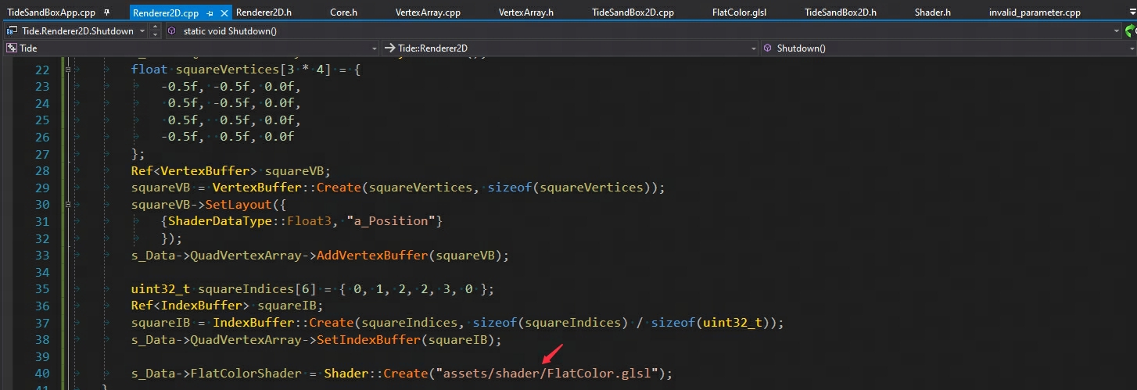

* 052 Added transforms and textures to Renderer2D  
  glsl的代码有误，vec4类型写成vec，抛出shader无法编译的异常

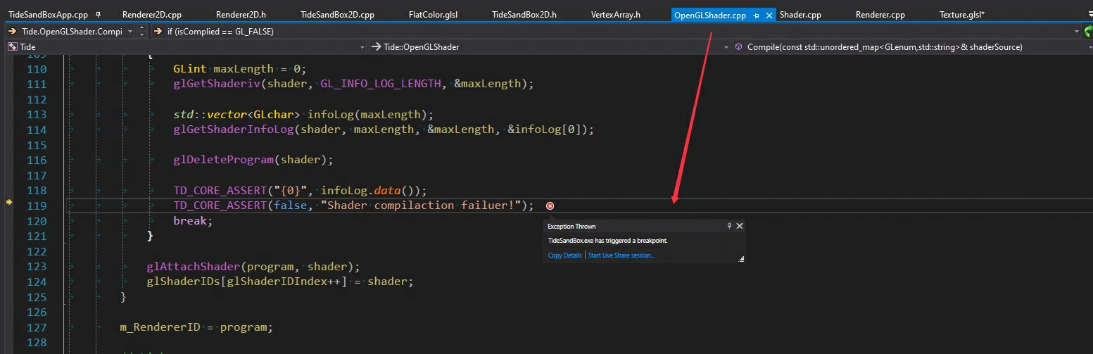

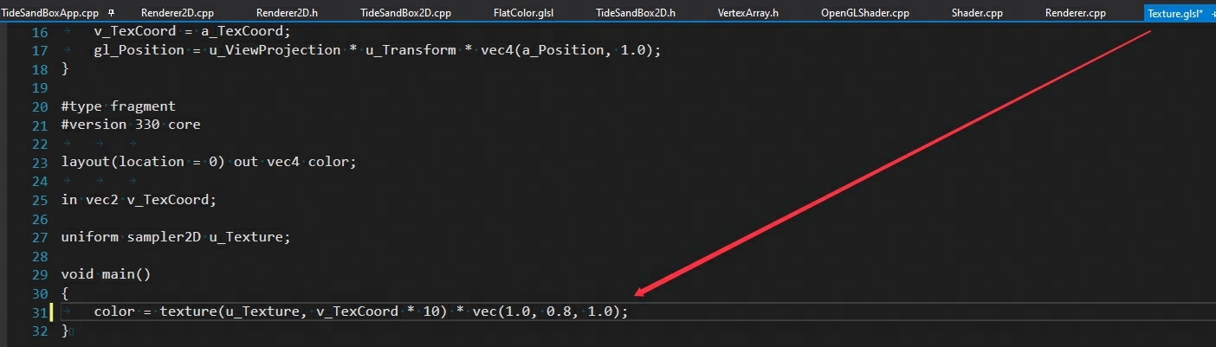

* 053 Renderer2D use a single shader to render box textured  
  “==” 写成 “=”，导致非贴图的Quad无法着色

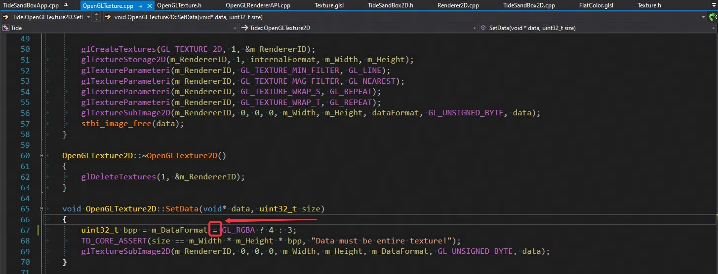

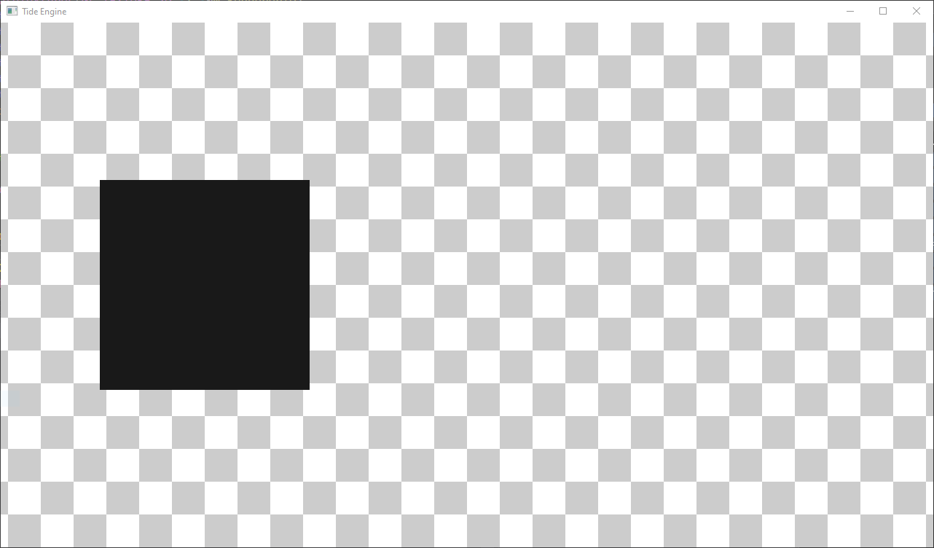

* 055 Renderer2D use a single shader to render box textured  
  spdlog不允许格式化非Void类型的指针(Formatting of non-void pointers is disallowed)

